***Project Interface***

***Introduction of the App:***

The main aim to build this app so can user order food online from home or any other location he/she wants the delivery.

***Tag Line:***

Fast & Fresh

***Benefit of this App:***

* There is no need to go to restaurant on foot.
* It gives you permission to set delivery location and then shows multiple choices to select the restaurant branch in your area.
* If you go physically in any restaurant, there is possibility that your desired item is not available or you have to wait so long sometimes due to other customers. But through online means there are no such mishaps usually.
* You can see the billing of your orders in Cart View.
* You can save foods of your choice also in Favorite.

***Customer functionality***

* Log-In functionality
* Sign-Up functionality
* User registration
* User can set delivery location of his/her choice.
* User can search food of choice
* User can scroll to select the varieties of any food.
* Price and rating is available for user help
* User can pay bill in cart view online or at the time of delivery.

***Interfaces***

***STEP 1:***

***Splash screen:***

Splash screen is the first screen display when you open the app. It contains normally the food app name with its Tagline and Logo.

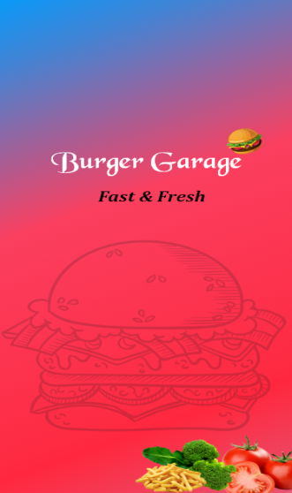

***STEP 2:***

***Log-in Screen:***

User can log-in if he is already registered.

* Enter his username or email address
* Enter the Password
* User can set new password by clicking ‘Forgot Password” if he forgets.
* Also log in with google account & face-book account

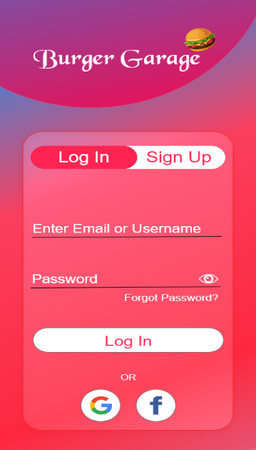

***STEP 3:***

***Sign-up Screen:***

Create the account or joining this app.

* Enter the username or email address
* Enter the password
* Confirm the password
* Click Sign up to go.

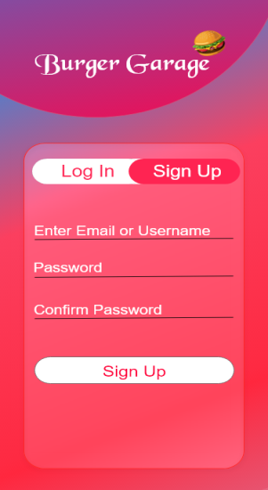

***STEP 4:***

***Home Screen:***

In this step, the shows its main functionality, user can search, select and order the food of choice.

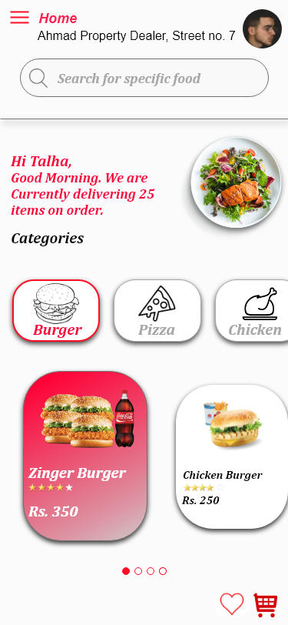

***STEP 5:***

***Location Screen***

This step shows the current location of delivery right below the home.

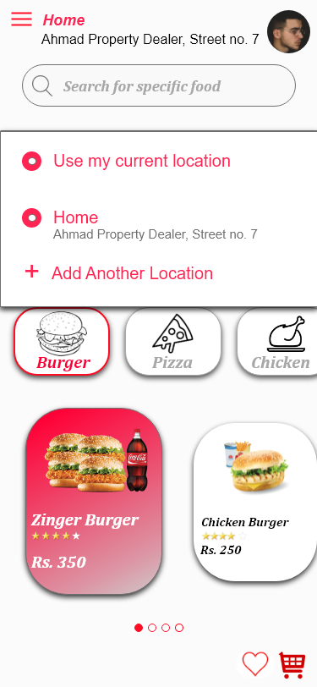

***STEP 6:***

***Add New Location***

In this step, user can set the location of his/her choice through google map.

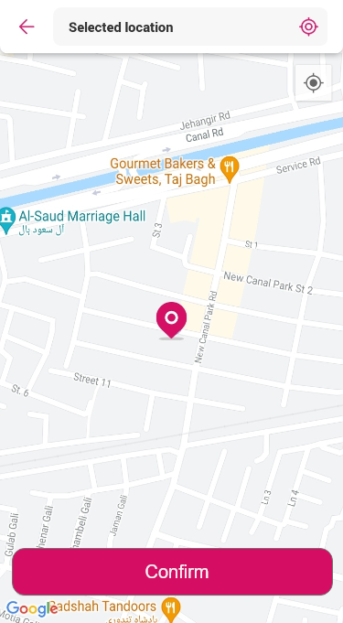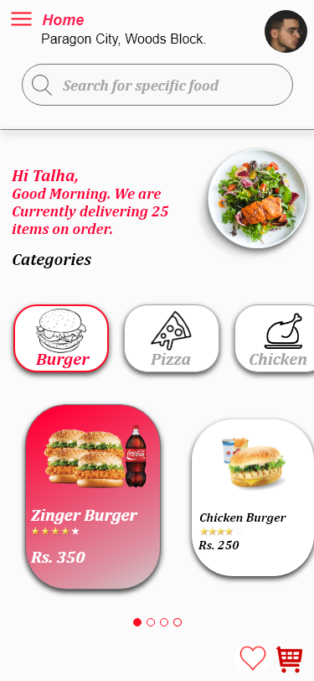

***MoodBoard:***

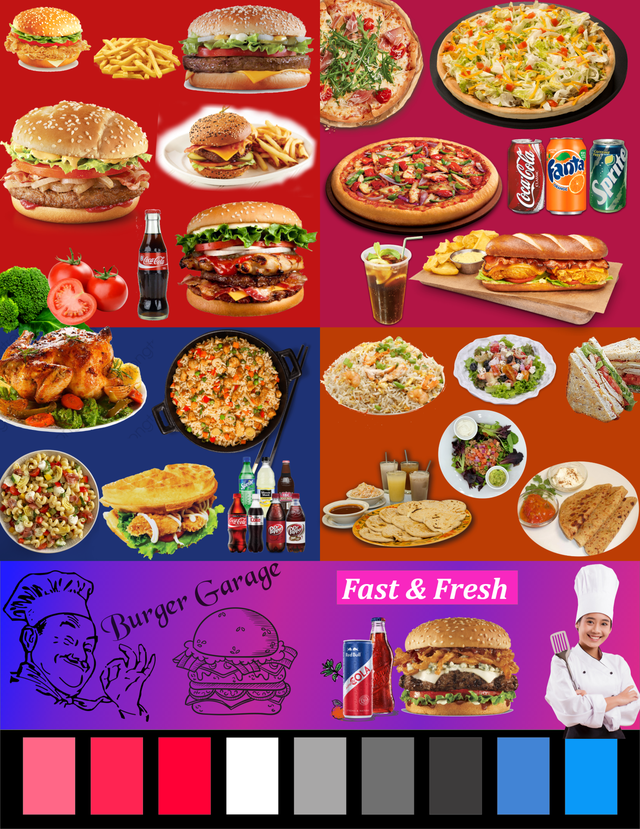

***Pattern Library:***



